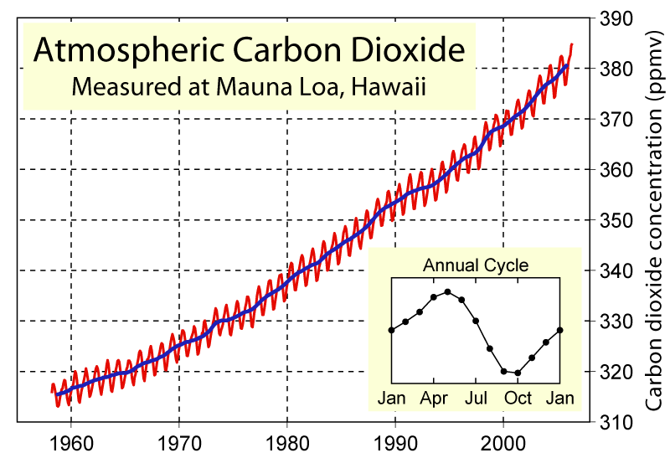

Graph found at http://www.globalwarmingart.com/images/8/88/Mauna_Loa_Carbon_Dioxide.png

Critical Thinking
Look at the CO₂ measured in the atmosphere by Ralph Keeling on Mauna Loa since 1955 (chart above). On a Google Doc, answer the following in complete sentences.

Use specific data from:
- Mauna Loa, Hawaii - Atmospheric CO₂ Graph and the
- Vostok, Antarctica CO₂ levels and Temperature Variation Graphs.

- What cause seasonal changes in green house gases (GHGs)? What causes the pattern? (Think back to your carbon cycle diagram and what processes move carbon around?) (4pts)
- What is the current level of CO₂ in the atmosphere today? (2pts)
- Is this CO₂ level in the normal range compared to your data from Vostok, Antarctica? (2pts)
- How is a growing 7 billion human population impacting greenhouse gases?much of the modern GHG change is natural and how much of it is us? Explain your reasoning. (3pts)
- What can we do about atmospheric CO₂ levels? List some solutions and ideas you have or what you have heard discussed in the media or in the news. (4pts)

