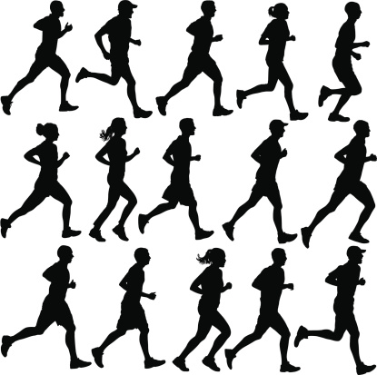
BREATHE IN, BREATHE FAT OUT
Researchers find 80 % of body fat leaves our body via the lungs.

The more you exercise, the better off you are health-wise, body-wise and mind- wise. What you might not know is 80% of the fat that leaves your body is expelled through your lungs. That’s right. You’re breathing away those pounds, according to recent research published in the British Medical Journal.
Human fat cells store triglyceride, a type of fat in the blood, which is made up of carbon, hydrogen and oxygen atoms. These atoms are released through oxidation and when that happens, fat is burned off. Scientists from the University of New South Wales in Australia did some math. When 22 pounds of fat is oxidized, 18.5 pounds leave the body through the lungs as CO₂. The remaining 3.5 pounds is loss as water. Oxygen needed to complete this process weighs nearly three times the fat being lost. So, to completely oxidize 22 pounds of human fat, 64 pounds of oxygen must be inhaled.
Example: A person weighing 154 pounds, at rest, takes 12 breaths a minute, or 17,280 breaths a day. That means they will lose at least 200 g or 0.44 pounds. And 1/3 of that weight is lost during eight hours of sleeping. Basically, thank your lungs. They’re the primary organ through which we lose weight. Also, keep exercising. Don't think breathing alone will accelerate your fat loss.

