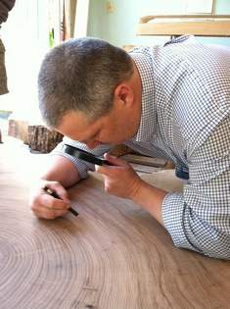
Tree Rings: Living Records of Climate
Background Information
Scientists use a variety of methods to collect data about the Earth’s weather and climate. Weather is defined as what is happening in the atmosphere at a specific time and place. Weather stations, balloons, buoys and satellites help humans gather information about Earth’s current weather conditions. Scientists learn about Earth’s past climate by studying patterns found in nature. Climate is defined as average weather conditions for at least 30 years. Evidence of the changes in climate can be trapped in trees, ice core, sediments, coral and stalagmites and used as “proxies” to estimate weather conditions hundreds and even millions of years ago. A proxy is defined as a physical characteristic of the past that is preserved AND can be substituted for a direct measurement. In order to identify a source of proxy data you must understand how patterns in nature are created.
Professor David Orwig, research forest ecologist from Harvard University counts tree rings of Elm Tree that grew in Ipswich, MA

Tree Rings
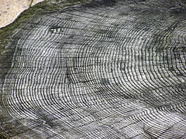
During each growing season (spring and summer), trees produce new wood in a ring located inside the bark. Wood made during the first part of the growing season is light in color and wood made later in the growing season is dark in color. A series of rings form during consecutive years of growth. Age of the tree can be determined by counting the number of rings, oldest to youngest, from the center of the tree outward towards the bark. A light and dark band together is the growth for one year. A single tree ring is an indicator of growing conditions over a single growing season. Rings can be evidence of environmental events such as floods, droughts, insect attacks, forest fires, lightning strikes, and even human development in an area. A thicker ring may indicate a longer growing season or more water availability depending on the environment and the species of the tree. A narrow ring may indicate a shorter or dryer growing season.
Each ring represents one year; the outside rings, near the bark, are the youngest rings

Tree rings can be used as, “climate proxy data,” providing indirect measurements of the past environment. Proxy data is when a scientist uses the measurement of a natural phenomenon or pattern in nature as a substitute for the measurement trying to be studied. For example, if enough trees in an area have been measured and scientists have a clear understanding what influences effected tree growth in that location, tree ring width can be substituted for temperature or moisture of a particular year.
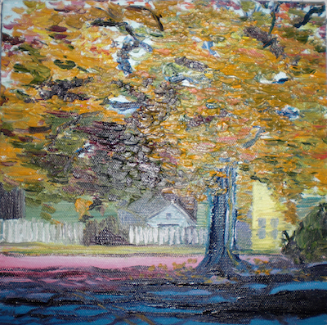
Factors which can affect ring width are:
- The age of the tree. The rate of growth varies through the life of the tree.
- Weather. In addition to temperature, ring growth is also affected by precipitation and to a lesser extent by wind speed and hours of sunshine.
- Previous years. If a tree has grown a lot in one year it is likely to grow a lot in following years and vice versa.
- Atmosphere. CO2 is necessary to growth and increased levels of CO2 can lead to enhanced growth.
- Competition. Other trees nearby or other plants can “rob” a particular tree of nutrients or light.
Small autumn painting of Ipswich’s Elm Tree
- Parasites. Infestation by insects or fungi can slow the growth of the tree.
Task
To practice gathering information from tree rings

Materials

- Hand Lens and magnifying glasses
- Ruler (metric)
- Pencil
- Calculator

- Various Tree Rings - Trees grown in Ipswich, MA that were cut down on January 9, 2015

Steps
1) Youtube Video “Tree Rings Explained” https://www.youtube.com/watch?v=IG44MW_iMmI
2) Using the materials listed above to analysis and gather the information asked for on the next page.
3) Read over the article:
- For the 3 images, finish the sentence, “I wonder ____________________________________.”
- Read article and circle words that you can’t describe out loud.
- Write a sentence that summarizes the ideas in the paragraph. (Find the 2 or 3 ideas that are repeated multiple times in the paragraph and describe how those concepts are connected.)

TREE RING #1
Location of tree (See materials list): ______________________________________________________
Name of species (See label on tree ring): __________________________________________________
Diameter of cross section: ________________________________________________________________
Radius of cross section: (diameter/2): _______________________________________________________
Date of death of tree (See materials list): __________________________________________________
Year of last growing season: ______________________________________________________________
Age of Tree (Count the number of dark rings): _________________________________________________
Year Tree was planted (year of last growing season – age of tree): ____________________________________
Find the light & dark band that is the widest. During which year did the tree grow the most? (Subtract the year of this ring from the year of last growing season) __________________________________________________
Find the light & dark band that is the thinnest. During which year did the tree grow the least? (Subtract the year of this ring from the year of last growing season) ______________________________________________
Average Rate of Growth per Year (Radius of cross section/Number of Years = Average Rate of Growth):
__________________________________________________________________________________________

TREE RING #2
Location of tree (See materials list): ______________________________________________________
Name of species (See label on tree ring): __________________________________________________
Diameter of cross section: ________________________________________________________________
Radius of cross section: (diameter/2): _______________________________________________________
Date of death of tree (See materials list): __________________________________________________
Year of last growing season: ______________________________________________________________
Age of Tree (Count the number of dark rings): _________________________________________________
Year Tree was planted (year of last growing season – age of tree): ____________________________________
Find the light & dark band that is the widest. During which year did the tree grow the most? (Subtract the year of this ring from the year of last growing season) __________________________________________________
Find the light & dark band that is the thinnest. During which year did the tree grow the least? (Subtract the year of this ring from the year of last growing season) ______________________________________________
Average Rate of Growth per Year (Radius of cross section/Number of Years = Average Rate of Growth):
__________________________________________________________________________________________

TREE RING #3
Location of tree (See materials list): ______________________________________________________
Name of species (See label on tree ring): __________________________________________________
Diameter of cross section: ________________________________________________________________
Radius of cross section: (diameter/2): _______________________________________________________
Date of death of tree (See materials list): __________________________________________________
Year of last growing season: ______________________________________________________________
Age of Tree (Count the number of dark rings): _________________________________________________
Year Tree was planted (year of last growing season – age of tree): ____________________________________
Find the light & dark band that is the widest. During which year did the tree grow the most? (Subtract the year of this ring from the year of last growing season) __________________________________________________
Find the light & dark band that is the thinnest. During which year did the tree grow the least? (Subtract the year of this ring from the year of last growing season) ______________________________________________
Average Rate of Growth per Year (Radius of cross section/Number of Years = Average Rate of Growth):
__________________________________________________________________________________________

COMPARING TREE RINGS

1) Which tree was the oldest? How old was this tree?

2) Which tree was the youngest? How old was this tree?

3) Which tree grew the fastest?

