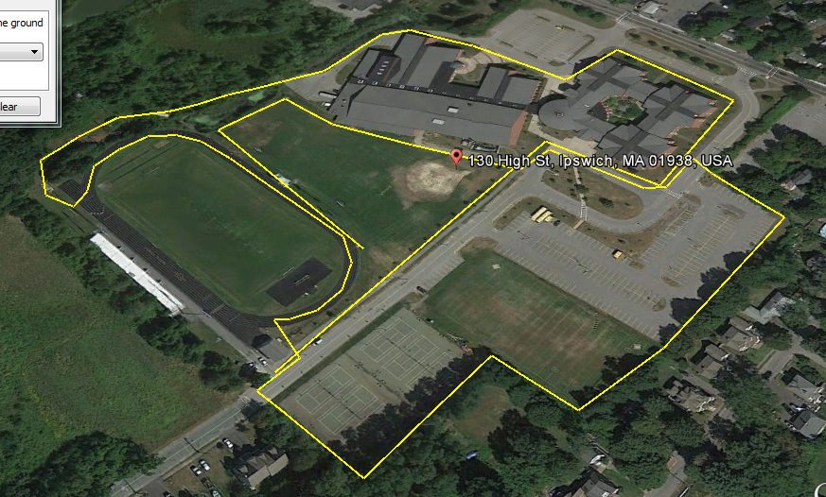
Star
Finish Line
Start of 1.29 mile course coursecocourse

